**Individual Weekly Report**

**Name: Simone Kang**

**Team:** Good AIM

**Date:** 2/17/25

| **Current Status** |
| --- |

1. What did you **personally** work on this past week?

| **Task** | **Status** | **Time Spent** |
| --- | --- | --- |
| Create login page | DONE | ~1hr |
| Make skeleton page & footer | IN PROGRESS | 1-2.5 hr |

Include **screenshots/graphics** to illustrate what you did this past week:

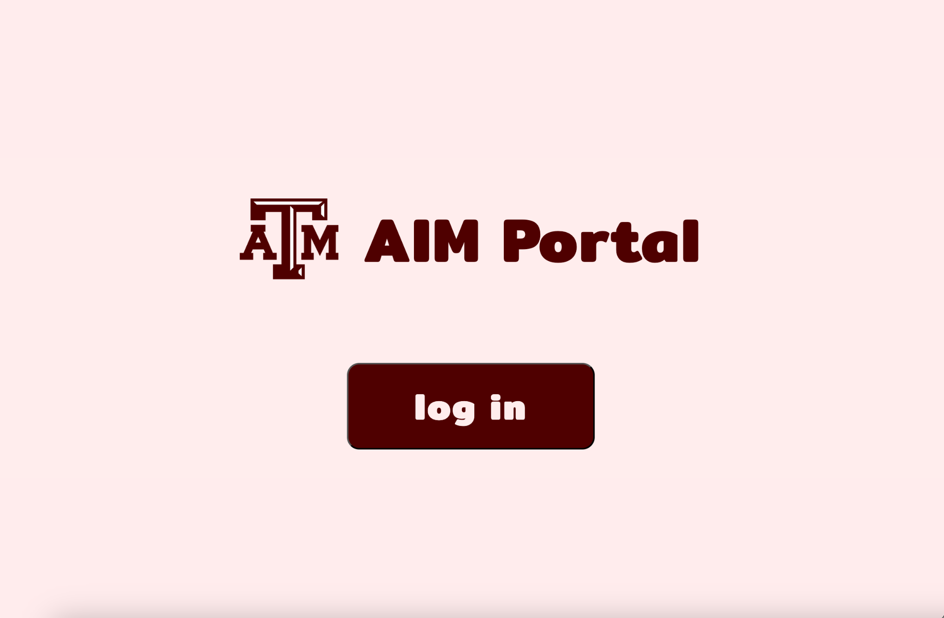

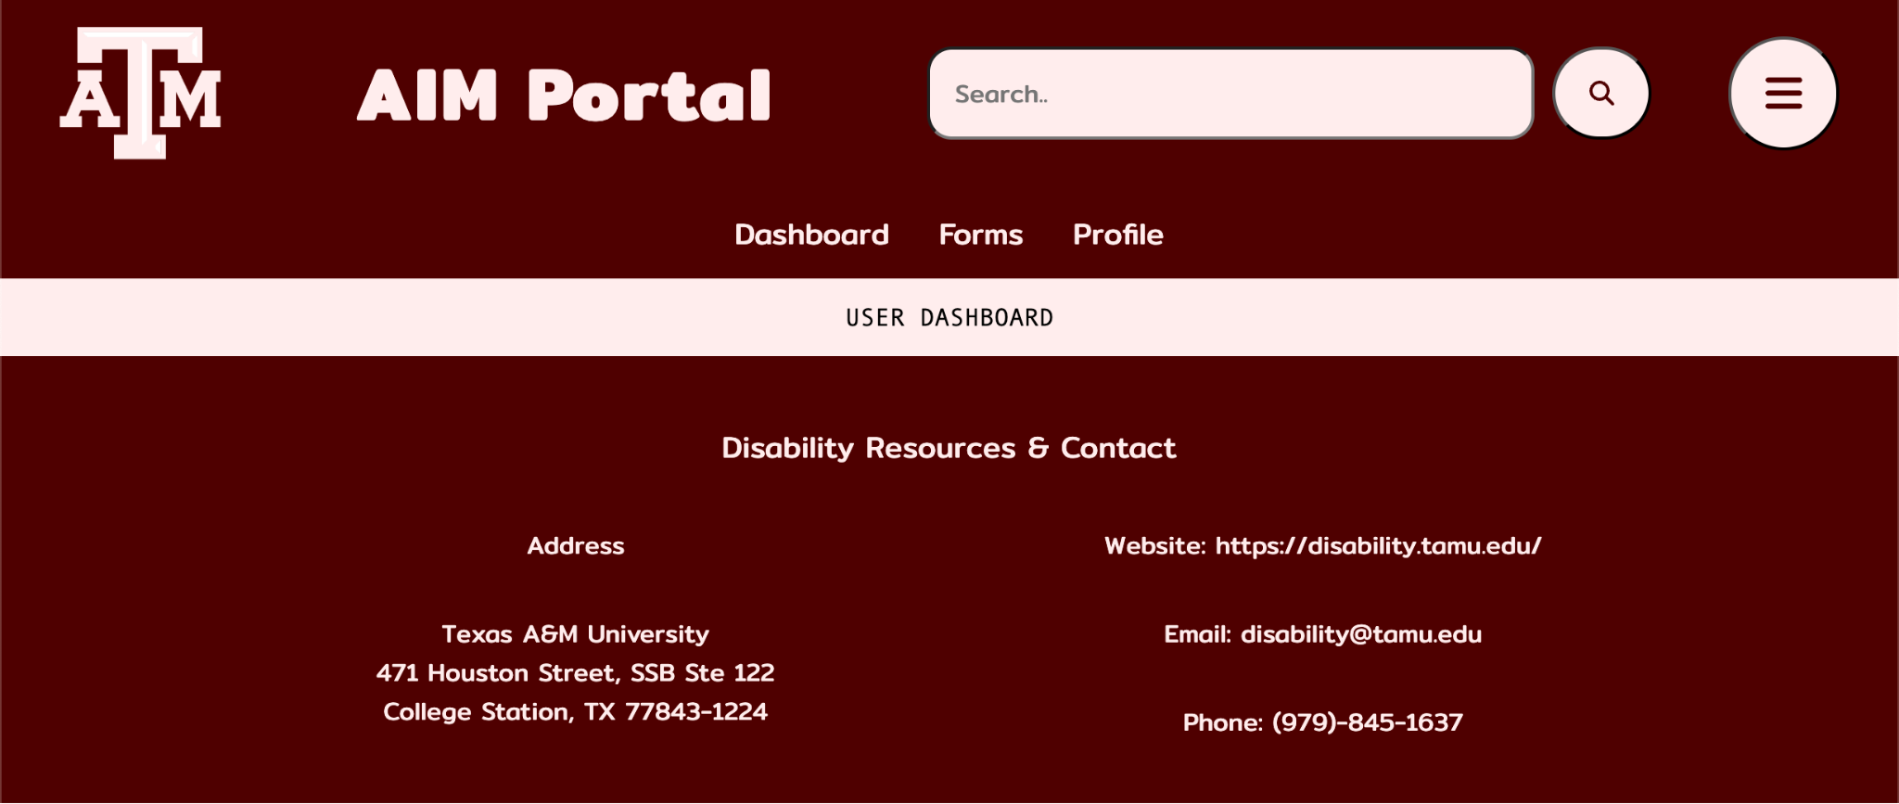

1. What problems did you run into? What is your plan for them?

The only problems we’ve run into so far have been with database entities and efficiency, and the issue of session times & extenders. We’ve decided to allow alerts to tell users when they are being signed out, and allow them to extend the session then.

1. What is the current overall project status from your perspective?

We have a great start, and we’re on track to finish our sprint with (hopefully) time to spare.

1. How is your team functioning from your perspective?

The team is functioning well, and we’re doing a great job of communication, teamwork, and delegation.

1. What new ideas did you have or skills did you develop this week?

Justin, our sponsor, sent us a recording of a walkthrough for the staff view, this brought up a lot of new ideas for features on that view. EX: session extender

1. Who was your most awesome team member this week and why?

Paul and Shreyas were the most awesome team members this week! They handled all the database setup and dummy data, all while learning Neon on the fly.

| **Plans for Next Week** |
| --- |

What are you going to work on this next week?

Do Oauth integration & login, finish up skeleton page and footer, and implement accessibility features